HUSSEY’S GENERAL STORE APPAREL ORDER FORM
To process your order by phone using your credit or debit card call 207-445-2511 and ask for our Clothing Department.
OR
To pay by check total your order and add shipping and tax. Send your check and a copy of this order to: Hussey’s General Store
PO Box 81
Windsor ME 04363

Note: Flat rate shipping charge will be applied to each order dependent on flat rate box size needed
Reminder: Make your checks payable for the total amount. Please contact us if you need assistance:
207-445-2511 or clothing@husseysgeneralstore.com

YOUR CONTACT INFORMATION:
Name:_______________________________________________________________________________
Shipping Address:______________________________________________________________________
Phone Number: (_____)______________________________________________________________
Email Address:_________________________________________________________________________
CIRCLE ITEM(S) YOU WOULD LIKE TO ORDER:
ITEM PRICE COLOR PREF SIZE
HUSSEY’S SIGN ADULT TEE | $19.99 | GREY  BLACK  WINE | S M L XL 2X 3X
HUSSEY’S SHOTGUN  WEDDING TEE | $19.99 | GREY  BLACK | S M L XL 2X 3X
HUSSEY’S “EMPLOYEE”  BACK LOGO TEE | $19.99 | NAVY ONLY | S M L XL 2X 3X 4X 5X
NEW HUSSEY’S LADIES LOGO TANK | $19.99 | BLACK  NAVY  ARMY GREEN  DARK GREY | S M L XL 2X
RUSH HOUR @  HUSSEY’S TEE | $15.99 | ASSORTED COLORS | S M L XL 2X 3X
HUSSEY’S/ WINDSOR  FAIR TEE | $15.99----------------------  $19.99---------------------- | SOLID  TIE DYE | S M L XL 2X 3X  S M L XL 2X
HUSSEY’S “MEET  THE LOCALS” TEE  SWEATSHIRT/CREW  SWEATSHIRT/HOOD | $15.99----------------------  $29.99----------------------  $34.99---------------------- | ASSORTED COLORS  ------------------------------  ------------------------------  ------------------------------ | S M L XL 2X 3X  S M L XL 2X 3X  S M L XL 2X 3X
PROPERTY OF  HUSSEY’S L/S TEE OR  SWEATSHIRT | $24.99----------------------  $29.99---------------------- | ASSORTED COLORS  -------------------------------  ------------------------------- | S M L XL 2X 3X  S M L XL 2X 3X
HUSSEY’S SIGN HOOD  SWEATSHIRT | $39.99 | NAVY  GREY | S M L XL 2X 3X
HUSSEY’S SIGN HAT | $15.99  $18.99  $17.99  $17.99  $15.99 | SOLID  CAMO  MESH BACK  WINTER KNIT  BLAZE ORANGE | ONE SZ/ ADJUSTABLE
HUSSEY’S FLEECE VEST | $34.99 | NAVY | S M L XL 2X
CHILDREN’S TEES  6M-4T, XS(2-4) S(6-8)  M(10-12) L(14-16)  XL(18-20) | INFANT ONESIE  NB-18M  $17.99 | ASSORTED COLORS
HUSSEY’S CHEST LOGO | $13.99 |  | XS S M L XL
RUSH HOUR @  HUSSEY’S | $13.99 |  | XS S M L XL

HUSSEY’S SIGN TEE: HUSSEY’S SHOTGUN WEDDING TEE:
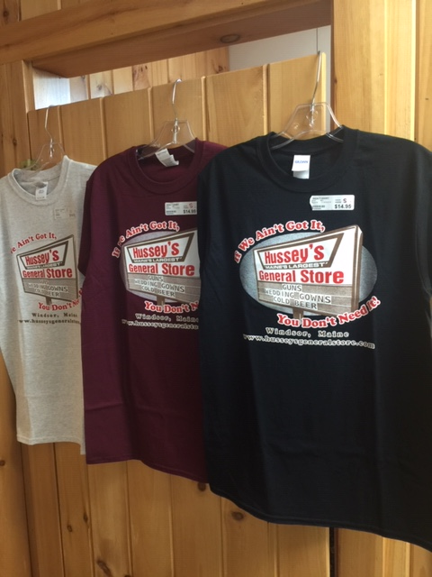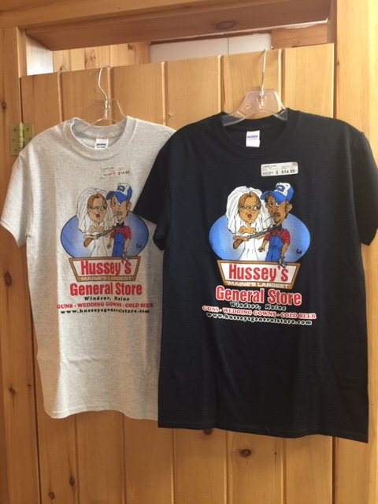

HUSSEY’S “EMPLOYEE” BACK LOGO TEE: NEW HUSSEY’S LADIES LOGO TANK:

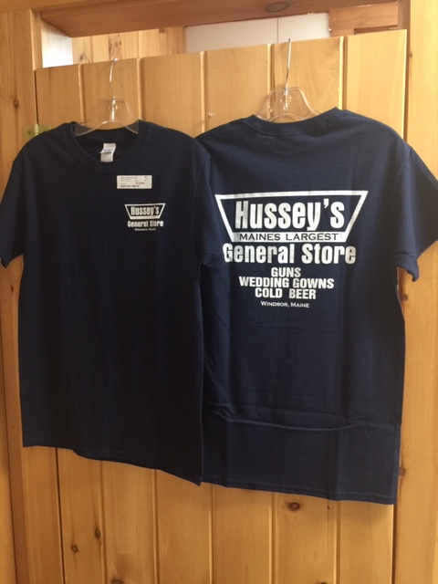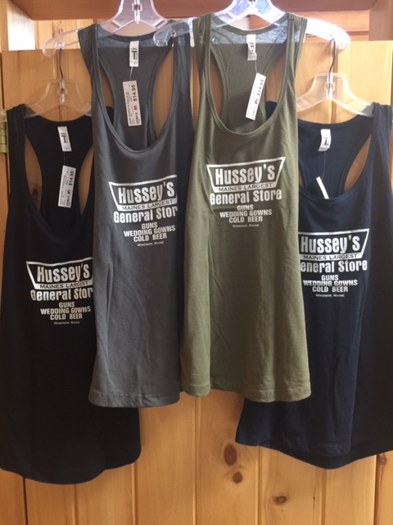

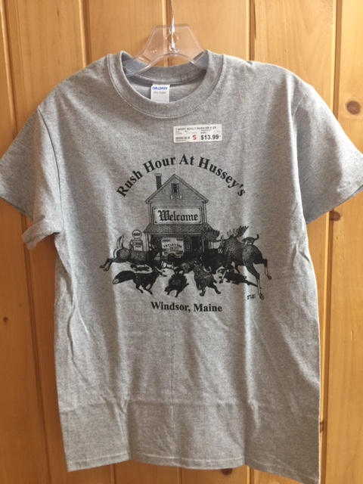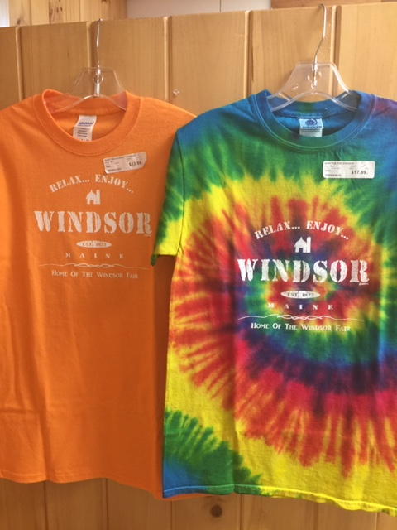
RUSH HOUR @HUSSEY’S TEE
HUSSEY’S /FAIR TEES

HUSSEY’S “MEET THE LOCALS” TEE: HUSSEY’S “MEET THE LOCALS” CREW/HOOD S-SHIRT:
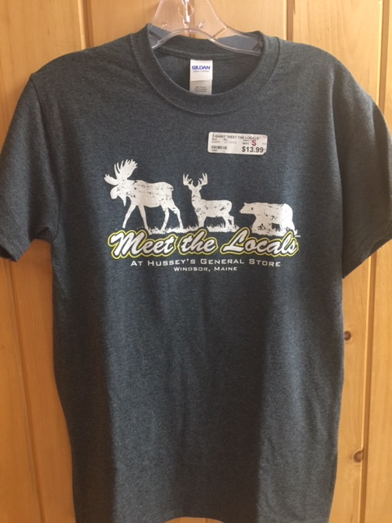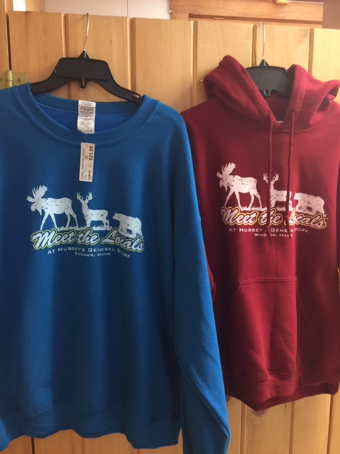
PROPERTY OF HUSSEY’S L/S TEE OR S-SHIRT:
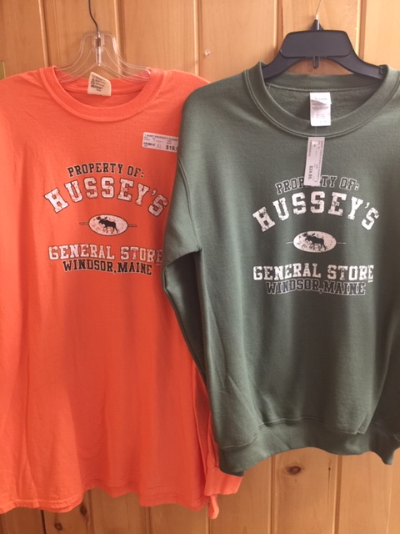

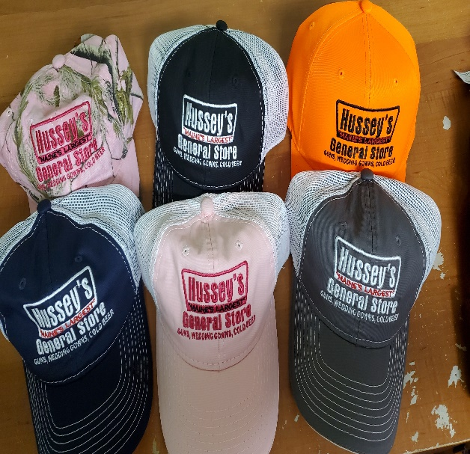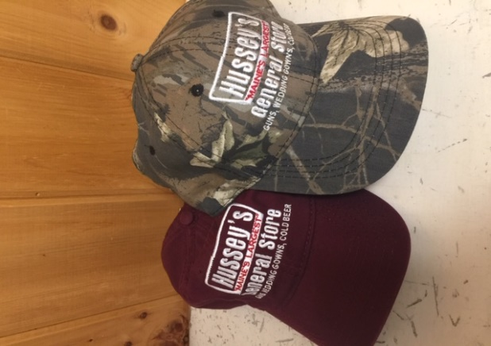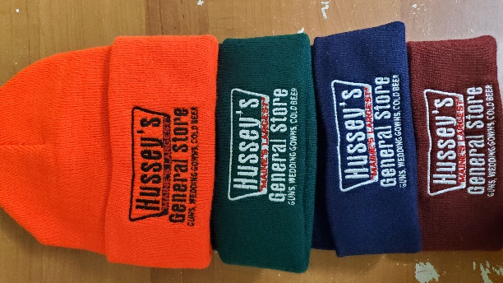
HUSSEY’S SIGN HATS
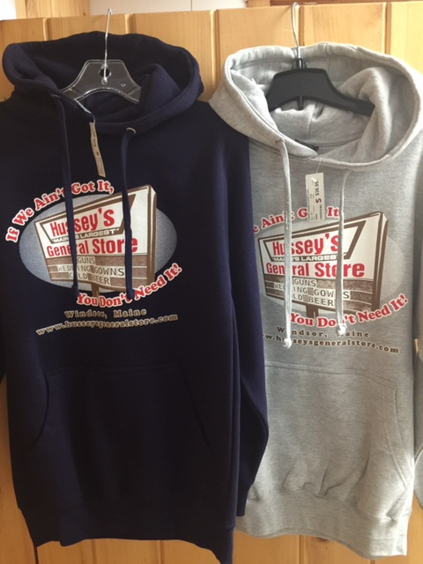
HUSSEY’S SIGN HOOD S-SHIRT

HUSSEY’S FLEECE VEST:
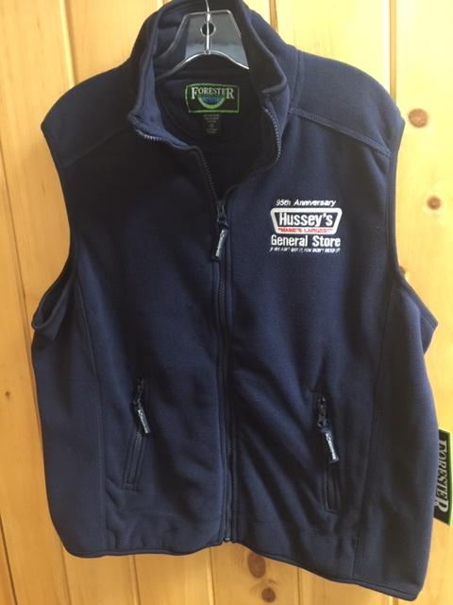

CHILDREN’S TEES
HUSSEY’S CHEST LOGO: RUSH HOUR @ HUSSEY’S
